Пензенский государственный университет
Кафедра «Вычислительная техника»

ОТЧЕТ
по лабораторной работе №3
по курсу «Основы ОС»
на тему: «Обработка исключительных ситуаций»

Выполнили студенты группы 23ВВП1 бригады 4:
Полиневский В.В.
Кизым И.А.
Проверили:

2026
Цель работы: изучить механизм обработки исключительных ситуаций.
Задачи: Модифицировать приложение из предыдущей лабораторной работы, реализовав проверку вводимых данных с использованием механизма исключений. Необходимо создать свой класс, унаследованный от класса Exception, и генерировать исключение, если возникает попытка создать экземпляр класса RecIntegral со значениями, не являющимися числами в диапазоне от 0,000001 до 1000000. В качестве обработки исключения необходимо выводить диалог, содержащий предупреждение о некорректности введенных данных.

Практическая часть:
Листинг класса MathFunction, предназначенного для подсчета интеграла:
public class MathFunction {
private double start_unacceptability_value = Math.PI / 2;
private double step_unacceptability_period = Math.PI;
private static double EPSILON = 1e-10;
private double max_x = 0;
private double min_x = 0;
private double step = 0;
private double result;
private double next_x_position = 0;
// возвращает точный необходимый шаг
private double checking_interval_for_unacceptability(double this_x, double this_step) {
double true_next_x = this_x + this_step;
double temp_start_unacceptability_value = start_unacceptability_value;
while (true) {
if (temp_start_unacceptability_value > true_next_x){
break;
}
if (temp_start_unacceptability_value < true_next_x && temp_start_unacceptability_value > this_x) {
next_x_position = temp_start_unacceptability_value + 0.01;
return this_step - (true_next_x - temp_start_unacceptability_value) - 0.001;
}
temp_start_unacceptability_value += step_unacceptability_period;
}
while (true) {
if (temp_start_unacceptability_value < this_x){
break;
}
if (temp_start_unacceptability_value < true_next_x && temp_start_unacceptability_value > this_x) {
next_x_position = temp_start_unacceptability_value + 0.01;
return this_step - (true_next_x - temp_start_unacceptability_value) - 0.001;
}
temp_start_unacceptability_value -= step_unacceptability_period;
}
return this_step;
}
private double get_true_step(double this_x, double this_step){
double this_part_area = 0;
double temp_step = this_step;
next_x_position = this_x + temp_step;
if (this_x + this_step > max_x) {
temp_step = max_x - this_x;
next_x_position = max_x;
}
if (isUnacceptablePoint(this_x + temp_step)){
next_x_position = temp_step + this_x + 0.001;
temp_step = temp_step - 0.001;
}
temp_step = checking_interval_for_unacceptability(this_x, temp_step);
return temp_step;
}
private double mathing_part_area(double this_x, double this_step){
double this_x_plus_step = this_x + this_step;
double funtion_at_this_x = Math.sin(this_x)/Math.cos(this_x);
double function_at_this_x_plus_step = Math.sin(this_x_plus_step)/Math.cos(this_x_plus_step);
return this_step * (funtion_at_this_x + function_at_this_x_plus_step) / 2;
}
private boolean isUnacceptablePoint(double x) {
double k = (x - Math.PI/2) / Math.PI;
double nearestInteger = Math.round(k);
return Math.abs(k - nearestInteger) < EPSILON;
}
private double calculation_result(){
if (isUnacceptablePoint(min_x)) {
min_x += 0.001;
}
// проверка min_x и max_x на некоректное значение
double this_x_position = min_x;
double local_step = 0;
double result_area = 0;

while (true){
if (this_x_position == max_x ){
break;
}
local_step = get_true_step(this_x_position, step);
result_area += mathing_part_area(this_x_position, local_step);
this_x_position = next_x_position;
}
return result_area;
}

public MathFunction(double _min_x, double _max_x, double _step) {
max_x = _max_x;
min_x = _min_x;
step = _step;
}
public double get_result(){
result = calculation_result();
return result;
}
}
Листинг main класса main_window:
/*
* Click nbfs://nbhost/SystemFileSystem/Templates/Licenses/license-default.txt to change this license
* Click nbfs://nbhost/SystemFileSystem/Templates/GUIForms/JFrame.java to edit this template
*/

/**
*
* @author admin_
*/
import javax.swing.JOptionPane;
import javax.swing.table.DefaultTableModel;

public class main_window extends javax.swing.JFrame {
private ControlerTableData this_ControlerTableData;
private double last_min_x;
private double last_max_x;
private double last_step;
private int count_input_data;
private static final java.util.logging.Logger logger = java.util.logging.Logger.getLogger(main_window.class.getName());

/**
* Creates new form main_window
*/
public main_window() {
initComponents();
init_obj_ControlerTableData();
}

/**
* This method is called from within the constructor to initialize the form.
* WARNING: Do NOT modify this code. The content of this method is always
* regenerated by the Form Editor.
*/
@SuppressWarnings("unchecked")
// <editor-fold defaultstate="collapsed" desc="Generated Code">
private void initComponents() {

jPanel1 = new javax.swing.JPanel();
jLabel1 = new javax.swing.JLabel();
jPanel2 = new javax.swing.JPanel();
jLabel2 = new javax.swing.JLabel();
jLabel3 = new javax.swing.JLabel();
jLabel4 = new javax.swing.JLabel();
jTextField1 = new javax.swing.JTextField();
jTextField2 = new javax.swing.JTextField();
jTextField3 = new javax.swing.JTextField();
jButton1 = new javax.swing.JButton();
jButton2 = new javax.swing.JButton();
jButton3 = new javax.swing.JButton();
jButton4 = new javax.swing.JButton();
jButton5 = new javax.swing.JButton();
jPanel3 = new javax.swing.JPanel();
jScrollPane1 = new javax.swing.JScrollPane();
jTable1 = new javax.swing.JTable();

setDefaultCloseOperation(javax.swing.WindowConstants.EXIT_ON_CLOSE);
setBackground(new java.awt.Color(51, 0, 51));

jPanel1.setBackground(new java.awt.Color(255, 153, 255));
jPanel1.setBorder(javax.swing.BorderFactory.createBevelBorder(javax.swing.border.BevelBorder.RAISED));

jLabel1.setText("ФУНКЦИЯ: tg(x)");

javax.swing.GroupLayout jPanel1Layout = new javax.swing.GroupLayout(jPanel1);
jPanel1.setLayout(jPanel1Layout);
jPanel1Layout.setHorizontalGroup(
jPanel1Layout.createParallelGroup(javax.swing.GroupLayout.Alignment.LEADING)
.addGroup(jPanel1Layout.createSequentialGroup()
.addContainerGap()
.addComponent(jLabel1, javax.swing.GroupLayout.PREFERRED_SIZE, 156, javax.swing.GroupLayout.PREFERRED_SIZE)
.addContainerGap(javax.swing.GroupLayout.DEFAULT_SIZE, Short.MAX_VALUE))
);
jPanel1Layout.setVerticalGroup(
jPanel1Layout.createParallelGroup(javax.swing.GroupLayout.Alignment.LEADING)
.addGroup(javax.swing.GroupLayout.Alignment.TRAILING, jPanel1Layout.createSequentialGroup()
.addGap(0, 6, Short.MAX_VALUE)
.addComponent(jLabel1))
);

jPanel2.setBackground(new java.awt.Color(255, 153, 255));

jLabel2.setText("MAX x:");

jLabel3.setText("MIN x:");

jLabel4.setText("ШАГ:");

jTextField1.addActionListener(this::jTextField1ActionPerformed);

jTextField2.addActionListener(this::jTextField2ActionPerformed);

jTextField3.addActionListener(this::jTextField3ActionPerformed);

jButton1.setText("ДОБАВИТЬ");
jButton1.addActionListener(this::jButton1ActionPerformed);

jButton2.setText("УДАЛИТЬ");
jButton2.addActionListener(this::jButton2ActionPerformed);

jButton3.setText("ВЫЧИСЛИТЬ");
jButton3.addActionListener(this::jButton3ActionPerformed);

jButton4.setText("ЗАПОЛНИТЬ");
jButton4.addActionListener(this::jButton4ActionPerformed);

jButton5.setText("ОЧИСТИТЬ");
jButton5.addActionListener(this::jButton5ActionPerformed);

javax.swing.GroupLayout jPanel2Layout = new javax.swing.GroupLayout(jPanel2);
jPanel2.setLayout(jPanel2Layout);
jPanel2Layout.setHorizontalGroup(
jPanel2Layout.createParallelGroup(javax.swing.GroupLayout.Alignment.LEADING)
.addGroup(jPanel2Layout.createSequentialGroup()
.addContainerGap()
.addGroup(jPanel2Layout.createParallelGroup(javax.swing.GroupLayout.Alignment.LEADING, false)
.addComponent(jLabel2, javax.swing.GroupLayout.DEFAULT_SIZE, javax.swing.GroupLayout.DEFAULT_SIZE, Short.MAX_VALUE)
.addComponent(jLabel3, javax.swing.GroupLayout.DEFAULT_SIZE, javax.swing.GroupLayout.DEFAULT_SIZE, Short.MAX_VALUE)
.addComponent(jLabel4, javax.swing.GroupLayout.DEFAULT_SIZE, javax.swing.GroupLayout.DEFAULT_SIZE, Short.MAX_VALUE))
.addPreferredGap(javax.swing.LayoutStyle.ComponentPlacement.UNRELATED)
.addGroup(jPanel2Layout.createParallelGroup(javax.swing.GroupLayout.Alignment.LEADING, false)
.addComponent(jTextField1, javax.swing.GroupLayout.DEFAULT_SIZE, 73, Short.MAX_VALUE)
.addComponent(jTextField3)
.addComponent(jTextField2))
.addPreferredGap(javax.swing.LayoutStyle.ComponentPlacement.RELATED, javax.swing.GroupLayout.DEFAULT_SIZE, Short.MAX_VALUE)
.addGroup(jPanel2Layout.createParallelGroup(javax.swing.GroupLayout.Alignment.LEADING, false)
.addComponent(jButton4, javax.swing.GroupLayout.DEFAULT_SIZE, javax.swing.GroupLayout.DEFAULT_SIZE, Short.MAX_VALUE)
.addComponent(jButton5, javax.swing.GroupLayout.DEFAULT_SIZE, javax.swing.GroupLayout.DEFAULT_SIZE, Short.MAX_VALUE))
.addGap(57, 57, 57)
.addGroup(jPanel2Layout.createParallelGroup(javax.swing.GroupLayout.Alignment.LEADING, false)
.addComponent(jButton1, javax.swing.GroupLayout.DEFAULT_SIZE, javax.swing.GroupLayout.DEFAULT_SIZE, Short.MAX_VALUE)
.addComponent(jButton3)
.addComponent(jButton2, javax.swing.GroupLayout.DEFAULT_SIZE, javax.swing.GroupLayout.DEFAULT_SIZE, Short.MAX_VALUE))
.addGap(39, 39, 39))
);
jPanel2Layout.setVerticalGroup(
jPanel2Layout.createParallelGroup(javax.swing.GroupLayout.Alignment.LEADING)
.addGroup(jPanel2Layout.createSequentialGroup()
.addContainerGap()
.addGroup(jPanel2Layout.createParallelGroup(javax.swing.GroupLayout.Alignment.LEADING, false)
.addGroup(jPanel2Layout.createParallelGroup(javax.swing.GroupLayout.Alignment.BASELINE)
.addComponent(jButton1, javax.swing.GroupLayout.DEFAULT_SIZE, javax.swing.GroupLayout.DEFAULT_SIZE, Short.MAX_VALUE)
.addComponent(jButton4))
.addComponent(jLabel2, javax.swing.GroupLayout.DEFAULT_SIZE, javax.swing.GroupLayout.DEFAULT_SIZE, Short.MAX_VALUE)
.addComponent(jTextField1, javax.swing.GroupLayout.PREFERRED_SIZE, javax.swing.GroupLayout.DEFAULT_SIZE, javax.swing.GroupLayout.PREFERRED_SIZE))
.addGroup(jPanel2Layout.createParallelGroup(javax.swing.GroupLayout.Alignment.LEADING)
.addGroup(jPanel2Layout.createSequentialGroup()
.addGap(3, 3, 3)
.addGroup(jPanel2Layout.createParallelGroup(javax.swing.GroupLayout.Alignment.BASELINE)
.addComponent(jLabel3)
.addComponent(jButton2))
.addGap(9, 9, 9))
.addGroup(javax.swing.GroupLayout.Alignment.TRAILING, jPanel2Layout.createSequentialGroup()
.addPreferredGap(javax.swing.LayoutStyle.ComponentPlacement.RELATED)
.addGroup(jPanel2Layout.createParallelGroup(javax.swing.GroupLayout.Alignment.BASELINE)
.addComponent(jTextField2, javax.swing.GroupLayout.PREFERRED_SIZE, javax.swing.GroupLayout.DEFAULT_SIZE, javax.swing.GroupLayout.PREFERRED_SIZE)
.addComponent(jButton5))))
.addGroup(jPanel2Layout.createParallelGroup(javax.swing.GroupLayout.Alignment.LEADING)
.addGroup(jPanel2Layout.createSequentialGroup()
.addGroup(jPanel2Layout.createParallelGroup(javax.swing.GroupLayout.Alignment.BASELINE)
.addComponent(jLabel4)
.addComponent(jButton3))
.addGap(0, 2, Short.MAX_VALUE))
.addGroup(jPanel2Layout.createSequentialGroup()
.addGap(3, 3, 3)
.addComponent(jTextField3, javax.swing.GroupLayout.PREFERRED_SIZE, 0, Short.MAX_VALUE)))
.addContainerGap())
);

jPanel3.setBackground(new java.awt.Color(255, 153, 255));

jTable1.setAutoCreateRowSorter(true);
jTable1.setBorder(javax.swing.BorderFactory.createLineBorder(new java.awt.Color(0, 0, 0)));
jTable1.setModel(new javax.swing.table.DefaultTableModel(
new Object [][] {
{null, null, null, null, null},
{null, null, null, null, null},
{null, null, null, null, null},
{null, null, null, null, null},
{null, null, null, null, null},
{null, null, null, null, null},
{null, null, null, null, null},
{null, null, null, null, null},
{null, null, null, null, null},
{null, null, null, null, null},
{null, null, null, null, null},
{null, null, null, null, null},
{null, null, null, null, null},
{null, null, null, null, null},
{null, null, null, null, null},
{null, null, null, null, null},
{null, null, null, null, null},
{null, null, null, null, null},
{null, null, null, null, null},
{null, null, null, null, null}
},
new String [] {
"N", "MAX X", "MIN Y", "ШАГ", "РЕЗУЛЬТАТ"
}
));
jTable1.setPreferredSize(new java.awt.Dimension(320, 447));
jScrollPane1.setViewportView(jTable1);
if (jTable1.getColumnModel().getColumnCount() > 0) {
jTable1.getColumnModel().getColumn(0).setPreferredWidth(5);
}

javax.swing.GroupLayout jPanel3Layout = new javax.swing.GroupLayout(jPanel3);
jPanel3.setLayout(jPanel3Layout);
jPanel3Layout.setHorizontalGroup(
jPanel3Layout.createParallelGroup(javax.swing.GroupLayout.Alignment.LEADING)
.addGroup(jPanel3Layout.createSequentialGroup()
.addGap(23, 23, 23)
.addComponent(jScrollPane1, javax.swing.GroupLayout.PREFERRED_SIZE, 552, javax.swing.GroupLayout.PREFERRED_SIZE)
.addContainerGap(24, Short.MAX_VALUE))
);
jPanel3Layout.setVerticalGroup(
jPanel3Layout.createParallelGroup(javax.swing.GroupLayout.Alignment.LEADING)
.addGroup(jPanel3Layout.createSequentialGroup()
.addContainerGap()
.addComponent(jScrollPane1, javax.swing.GroupLayout.PREFERRED_SIZE, 475, javax.swing.GroupLayout.PREFERRED_SIZE)
.addContainerGap(24, Short.MAX_VALUE))
);

javax.swing.GroupLayout layout = new javax.swing.GroupLayout(getContentPane());
getContentPane().setLayout(layout);
layout.setHorizontalGroup(
layout.createParallelGroup(javax.swing.GroupLayout.Alignment.LEADING)
.addComponent(jPanel1, javax.swing.GroupLayout.DEFAULT_SIZE, javax.swing.GroupLayout.DEFAULT_SIZE, Short.MAX_VALUE)
.addComponent(jPanel2, javax.swing.GroupLayout.DEFAULT_SIZE, javax.swing.GroupLayout.DEFAULT_SIZE, Short.MAX_VALUE)
.addGroup(layout.createSequentialGroup()
.addComponent(jPanel3, javax.swing.GroupLayout.PREFERRED_SIZE, javax.swing.GroupLayout.DEFAULT_SIZE, javax.swing.GroupLayout.PREFERRED_SIZE)
.addGap(0, 0, Short.MAX_VALUE))
);
layout.setVerticalGroup(
layout.createParallelGroup(javax.swing.GroupLayout.Alignment.LEADING)
.addGroup(layout.createSequentialGroup()
.addComponent(jPanel1, javax.swing.GroupLayout.PREFERRED_SIZE, javax.swing.GroupLayout.DEFAULT_SIZE, javax.swing.GroupLayout.PREFERRED_SIZE)
.addPreferredGap(javax.swing.LayoutStyle.ComponentPlacement.RELATED)
.addComponent(jPanel2, javax.swing.GroupLayout.PREFERRED_SIZE, javax.swing.GroupLayout.DEFAULT_SIZE, javax.swing.GroupLayout.PREFERRED_SIZE)
.addPreferredGap(javax.swing.LayoutStyle.ComponentPlacement.RELATED)
.addComponent(jPanel3, javax.swing.GroupLayout.PREFERRED_SIZE, javax.swing.GroupLayout.DEFAULT_SIZE, javax.swing.GroupLayout.PREFERRED_SIZE)
.addContainerGap())
);

pack();
}// </editor-fold>

private void jTextField1ActionPerformed(java.awt.event.ActionEvent evt) {
// TODO add your handling code here:
}

private void jTextField2ActionPerformed(java.awt.event.ActionEvent evt) {
// TODO add your handling code here:
}

private void jTextField3ActionPerformed(java.awt.event.ActionEvent evt) {
// TODO add your handling code here:
}
//инициализация поля класса this_ControlerTableData, выступающего интерфейсом над данными таблицы
private void init_obj_ControlerTableData() {
DefaultTableModel model_table = (DefaultTableModel) jTable1.getModel();
this_ControlerTableData = new ControlerTableData(model_table);
}
// обработка клика на кнопку: вычислить
private void jButton3ActionPerformed(java.awt.event.ActionEvent evt) {
int rowIndex = jTable1.getSelectedRow();
if (rowIndex == -1) {
JOptionPane.showMessageDialog(this, "строка не выбрана");
return;
}
this_ControlerTableData.show_integral_at_index(rowIndex);
//this_ControlerTableData.show_last_integral();
return;
}
// обработка клика на кнопку: добавить
private void jButton1ActionPerformed(java.awt.event.ActionEvent evt) {
DefaultTableModel model_table = (DefaultTableModel) jTable1.getModel();
if (model_table.getRowCount() > 0 && model_table.getValueAt(0, 0) == null) {
model_table.setRowCount(0);
}
String string_max_x = jTextField1.getText();
String string_min_x = jTextField2.getText();
String string_step = jTextField3.getText();
if (string_max_x.isEmpty() || string_min_x.isEmpty() || string_step.isEmpty()) {
JOptionPane.showConfirmDialog(this, "Заполните все поля");
return;
}
double double_max_x = Double.parseDouble(string_max_x);
double double_min_x = Double.parseDouble(string_min_x);
double double_step = Double.parseDouble(string_step);
try {
this_ControlerTableData.push_back_input_data(double_max_x, double_min_x, double_step);
}
catch (InputValueException exc) {
JOptionPane.showConfirmDialog(this, exc.get_exc_message() + Double.toString(exc.get_ex_value()));
}
jTable1.repaint();
jTable1.revalidate();
count_input_data++;
return;
//jTextField1.setText("");
//jTextField2.setText("");
//jTextField3.setText("");
}
// обработка клика на кнопку: удалить
private void jButton2ActionPerformed(java.awt.event.ActionEvent evt) {
int rowIndex = jTable1.getSelectedRow();
if (rowIndex == -1) {
JOptionPane.showMessageDialog(this, "строка не выбрана");
return;
}
// DefaultTableModel model_table = (DefaultTableModel) jTable1.getModel();
// if (count_input_data > 0) {
// this_ControlerTableData.remove_last();
// count_input_data -= 1;
// }
// else {
// JOptionPane.showMessageDialog(this, "Таблица пуста!");
// }
this_ControlerTableData.remove_row_at_index(rowIndex);
return;
}
// обработка клика на кнопку: заполнить
private void jButton4ActionPerformed(java.awt.event.ActionEvent evt) {
this_ControlerTableData.clear_table_data();
this_ControlerTableData.show_all_data_rows();
}
// обрабокта клика на кнопку: очистить
private void jButton5ActionPerformed(java.awt.event.ActionEvent evt) {
this_ControlerTableData.clear_table_data();
}

/**
* @param args the command line arguments
*/
public static void main(String args[]) {
/* Set the Nimbus look and feel */
//<editor-fold defaultstate="collapsed" desc=" Look and feel setting code (optional) ">
/* If Nimbus (introduced in Java SE 6) is not available, stay with the default look and feel.
* For details see http://download.oracle.com/javase/tutorial/uiswing/lookandfeel/plaf.html
*/
try {
for (javax.swing.UIManager.LookAndFeelInfo info : javax.swing.UIManager.getInstalledLookAndFeels()) {
if ("Nimbus".equals(info.getName())) {
javax.swing.UIManager.setLookAndFeel(info.getClassName());
break;
}
}
} catch (ReflectiveOperationException | javax.swing.UnsupportedLookAndFeelException ex) {
logger.log(java.util.logging.Level.SEVERE, null, ex);
}
//</editor-fold>

/* Create and display the form */
java.awt.EventQueue.invokeLater(() -> new main_window().setVisible(true));
}
// Variables declaration - do not modify
private javax.swing.JButton jButton1;
private javax.swing.JButton jButton2;
private javax.swing.JButton jButton3;
private javax.swing.JButton jButton4;
private javax.swing.JButton jButton5;
private javax.swing.JLabel jLabel1;
private javax.swing.JLabel jLabel2;
private javax.swing.JLabel jLabel3;
private javax.swing.JLabel jLabel4;
private javax.swing.JPanel jPanel1;
private javax.swing.JPanel jPanel2;
private javax.swing.JPanel jPanel3;
private javax.swing.JScrollPane jScrollPane1;
private javax.swing.JTable jTable1;
private javax.swing.JTextField jTextField1;
private javax.swing.JTextField jTextField2;
private javax.swing.JTextField jTextField3;
// End of variables declaration
}
Листинг класса RecIntegral, реалзиующего функционал сущности одной записи таблицы:
public class RecIntegral {
private double max_x = 0.0;
private double min_x = 0.0;
private double step = 0.0;
private double integral = 0.0;
boolean flag_prev_mathing = false;

public RecIntegral(double _max_x, double _min_x, double _step) {
max_x = _max_x;
min_x = _min_x;
step = _step;
}
public double get_integral() {
if (flag_prev_mathing == false) {
MathFunction obj_MathFunction = new MathFunction(min_x, max_x, step);
integral = obj_MathFunction.get_result();
flag_prev_mathing = true;
}
return integral;
}
public double get_max_x(){return max_x;}
public double get_min_x(){return min_x;}
public double get_step(){return step;}
}
Листинг класса ControlerTableData, реализующего функционал интерфейса над таблицей, и колекцией объектов LinkedList:
/*
* Click nbfs://nbhost/SystemFileSystem/Templates/Licenses/license-default.txt to change this license
* Click nbfs://nbhost/SystemFileSystem/Templates/Classes/Class.java to edit this template
*/

/**
*
* @author admin_
*/
import javax.swing.table.DefaultTableModel;
import java.util.LinkedList;

public class ControlerTableData {
private DefaultTableModel table_model;
private LinkedList <RecIntegral> LinkedListRecIntegral;

public ControlerTableData(DefaultTableModel _table_model){
table_model = _table_model;
LinkedListRecIntegral = new LinkedList <RecIntegral> ();
}
public void remove_last(){
if (LinkedListRecIntegral.size() > 0) {
table_model.removeRow(LinkedListRecIntegral.size() - 1);
LinkedListRecIntegral.removeLast();
}
return;
}
public void remove_row_at_index(int index_Row) {
table_model.removeRow(index_Row);
LinkedListRecIntegral.remove(index_Row);
}

public boolean check_invalid_value (double value_double) {
if (value_double < 0.000001 || value_double > 1000000.0) {
return true;
}
return false;
}

public void show_all_data_rows(){
table_model.setRowCount(0);
for (int i = 0; i < LinkedListRecIntegral.size(); i++) {
double local_max_x = LinkedListRecIntegral.get(i).get_max_x();
double local_min_x = LinkedListRecIntegral.get(i).get_min_x();
double local_step = LinkedListRecIntegral.get(i).get_step();
double local_integral = LinkedListRecIntegral.get(i).get_integral();
table_model.addRow(new Object []{i + 1,local_max_x,local_min_x,local_step,local_integral});
table_model.fireTableDataChanged();
}
table_model.fireTableDataChanged();
return;
}
public void clear_table_data() {
table_model.setRowCount(0);
return;
}
public void show_last_integral(){
double local_integral = LinkedListRecIntegral.getLast().get_integral();
table_model.setValueAt(local_integral, LinkedListRecIntegral.size()-1,4);
}
public void show_integral_at_index(int indexRow){
double local_integral = LinkedListRecIntegral.get(indexRow).get_integral();
table_model.setValueAt(local_integral, indexRow, 4);
}
public void push_back_input_data(double max_x, double min_x, double step) throws InputValueException{
if (check_invalid_value(max_x)){
throw new InputValueException("Uncorectable max_x value:" , max_x);
}
if (check_invalid_value(min_x)){
throw new InputValueException("Uncorectable min_x value: ", min_x);
}
if (check_invalid_value(step)){
throw new InputValueException("Uncorectable step value: ", step);
}
if (max_x < min_x) {
throw new InputValueException("min_x > max_x, min_x: ", min_x);
}
if (step > max_x - min_x ) {
throw new InputValueException("step > dif max_x and min_x, step: ", step);
}
RecIntegral obj_RecIntegral = new RecIntegral(max_x, min_x, step);
LinkedListRecIntegral.add(obj_RecIntegral);
table_model.addRow(new Object []{LinkedListRecIntegral.size(),max_x,min_x,step, null});
}

}
Листинг класса InputValueException, унаследованного от Exception и являющегося классом исключения для некоректного значения числа.
public class InputValueException extends Exception {
private String exc_message = "";
private double ex_double_value;
public InputValueException (String ex_mes, double ex_val) {
exc_message = ex_mes;
ex_double_value = ex_val;
}
public String get_exc_message () {return exc_message;}
public double get_ex_value() {return ex_double_value;}
}

Отладка:
В отладке описан только добавленный функционал в соответсвии с заданием на лабораторную работу, а имено обработка исключительных ситуаций, связанных с введенными значениеями полей max_x, min_x, step на интервалах: (double.min ; 0,000001) || (1000000 ; double.max).
Ввели в приложеннии с графическим интерфейсом значения: 0.0000001 ; 0.0; 0.0 для полей max_x, min_x и шаг соответсвенно.
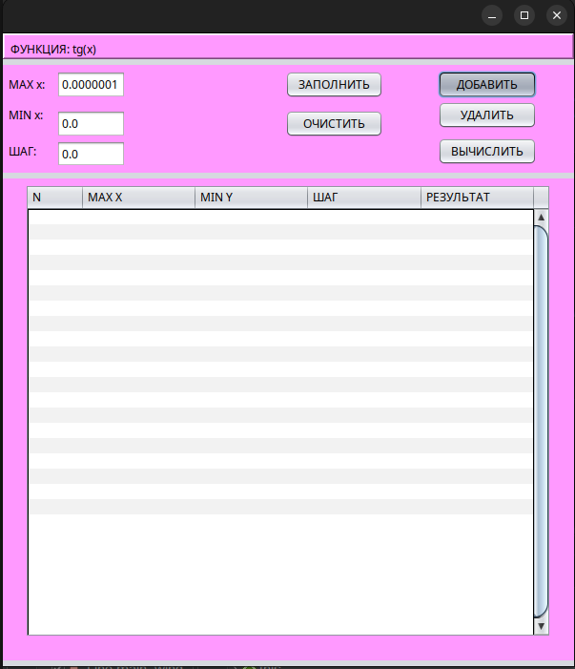
Первая точка остановки, фунция JButton1ActionPerformed(...).
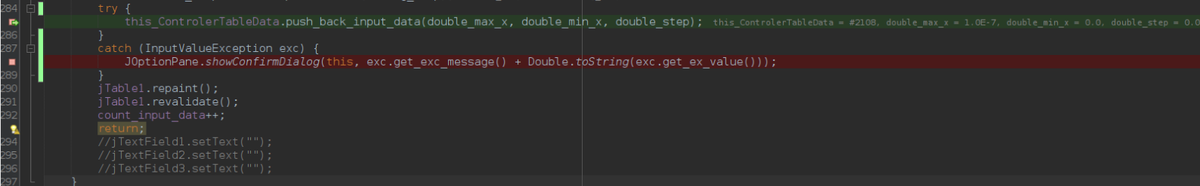
Вторая точка остановки, метод push_back_input_data(). Выкинуто исключение:
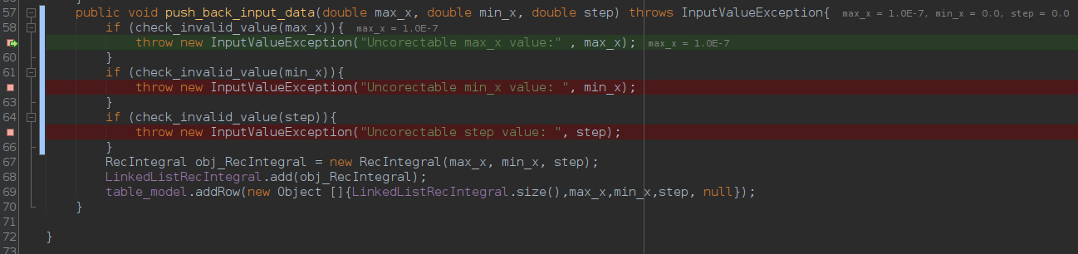
Третья точка остновки, JButton1ActionPerformed, обработка исключение, после выполнения функции видим сообщение:
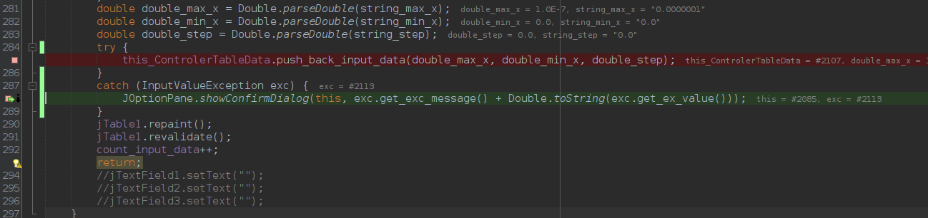
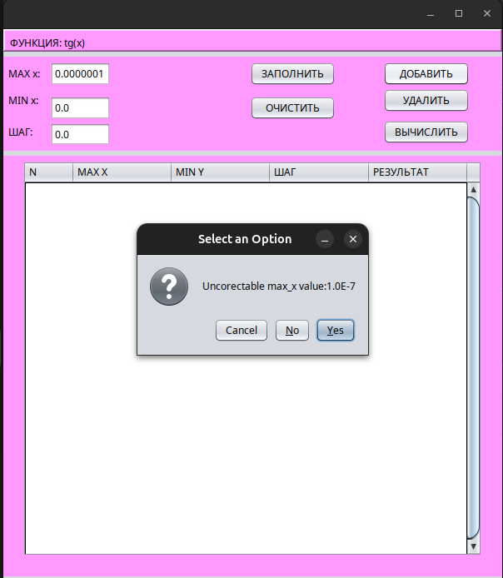

Ввели в приложеннии с графическим интерфейсом значения: 0.0; 10000000.0; 0.0 для полей max_x, min_x и шаг соответсвенно.
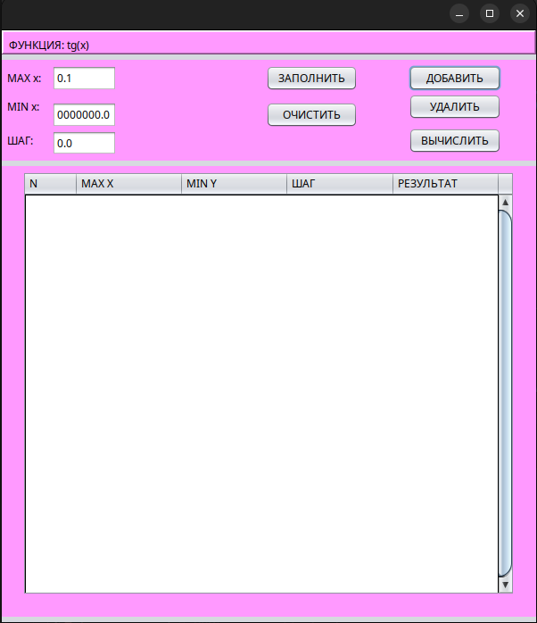
Четвертая точка остановки, фунция JButton1ActionPerformed(...). Попытка выполнения.
Пятая точка остановки, метод push_back_input_data(). Выкинуто исключение:
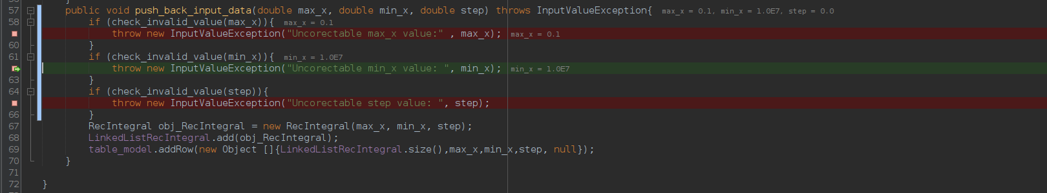

Шестая точка остновки, JButton1ActionPerformed, обработка исключение, после выполнения функции видим сообщение:
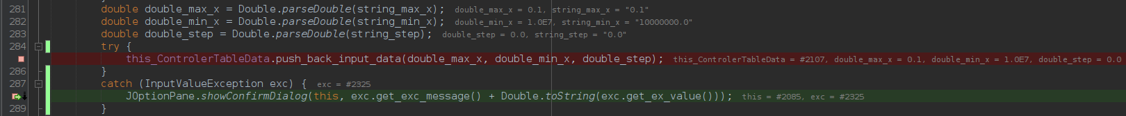
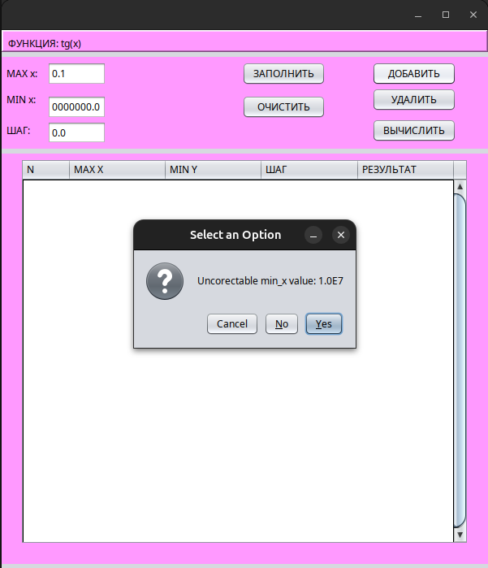
Ввели в приложеннии с графическим интерфейсом значения: 0.1; 0.1; 10000000.0 для полей max_x, min_x и шаг соответсвенно.
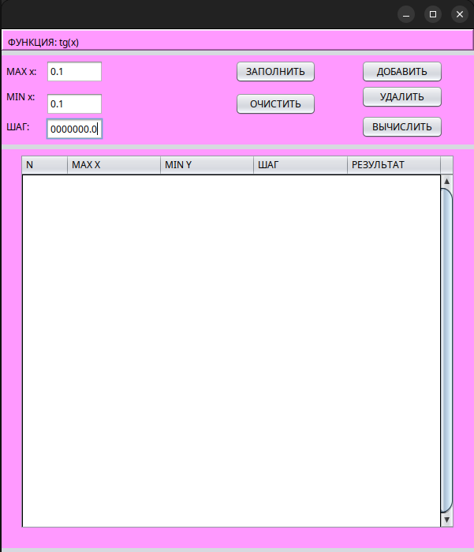
Седьмая точка остановки, фунция JButton1ActionPerformed(...). Попытка выполнения.
Восьмая точка остановки, метод push_back_input_data(). Выкинуто исключение:
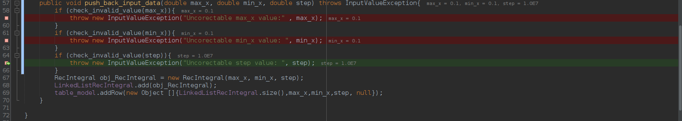
Девятая точка остновки, JButton1ActionPerformed, обработка исключение, после выполнения функции видим сообщение:
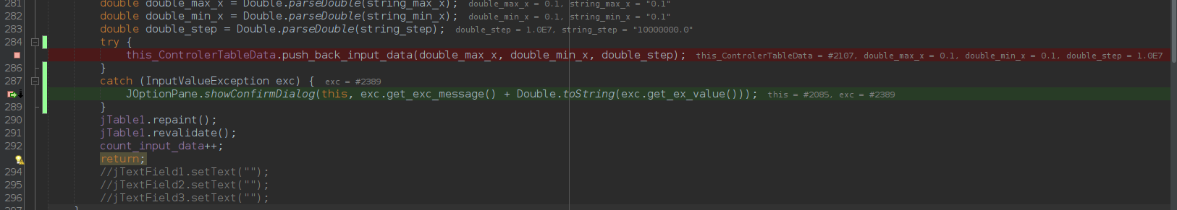
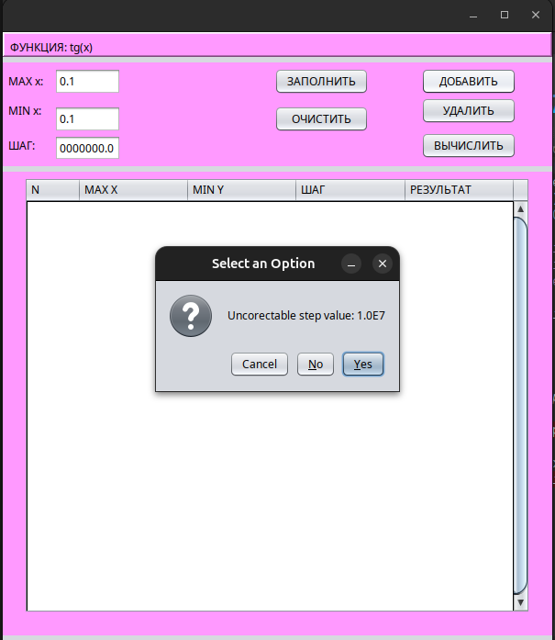
Выводы: В резульате выполнения лабораторной работы познакомились с обработкой исключений в языке Java.

